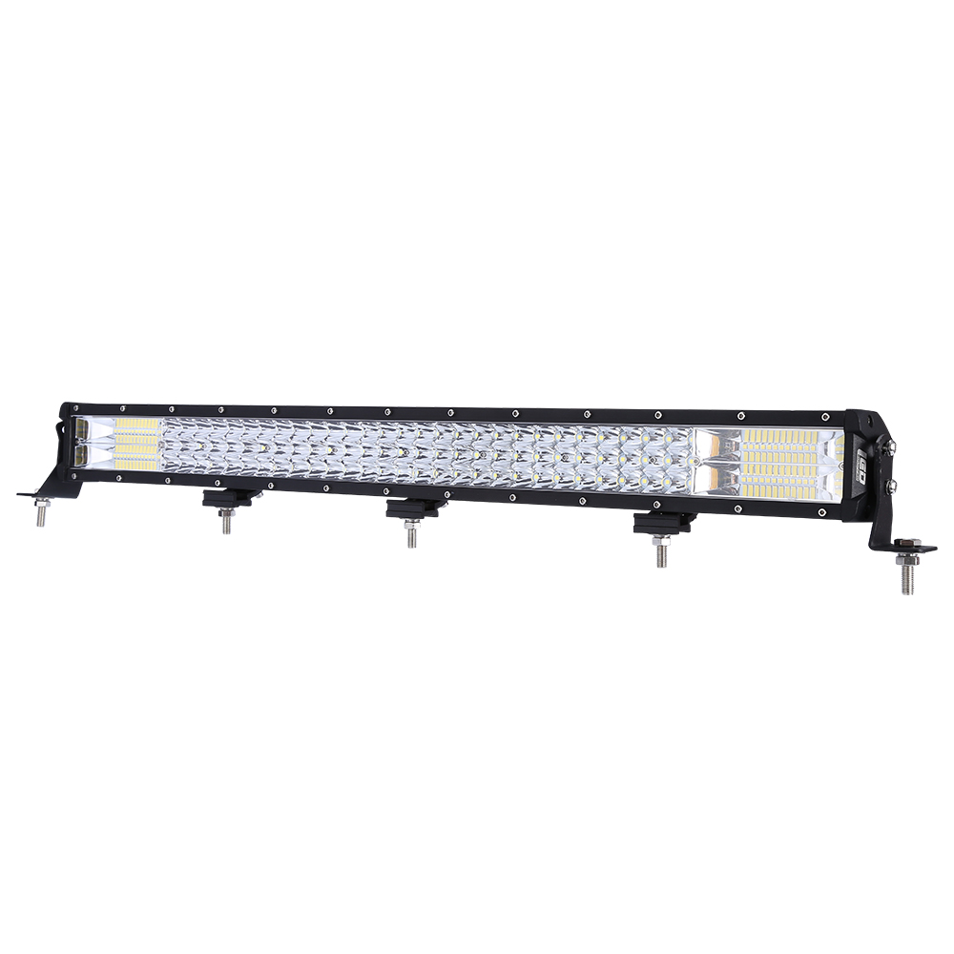

Prairie Falcon 31 Inch

Off Road LED Light Bar
Operating Manual and Installation Instructions

Prairie Falcon 31 Inch Off Road LED Light Bar

Operating Manual and Installation Instructions

Warnings and Notices for Users and Installers
WARNING: Take CAUTION when installing
This document must be delivered to and read by the end user and installer as it serves to provide you with the required information for proper and safe use of your LED Equipped product. Before operating this or any LED Equipped products the user and installer must read this manual all the way through. You will find important information in this manual that could prevent property damage and/or serious injury to the user and installer.
Your LED Equipped off road devices should be tested prior to use to insure the device and all its functions are operating correctly. If you experience a malfunction contact LED Equipped's Customer Service immediately for troubleshooting options, or a warranty or service claim. LED Equipped off road lights are not intended for, and should not be used for on-road travel or driving. Use of LED Equipped’s off road lights when travelling on state and local roadways may interfere with your or another driver’s visibility and can cause serious injury or death. LED Equipped is not responsible for improper use of off road driving lights installed on your vehicle and/or any injuries or damages caused by improper on road use of off road driving lights. DO NOT USE LED EQUIPPED OFF ROAD LIGHTS WHILE DRIVING ON STATE OR LOCAL ROADWAYS.
This is professional grade equipment and is intended for strict use for off road driving. It is the user's responsibility to understand and obey all laws regarding the use of off road lights installed on your vehicle. You must know and be familiar with all applicable city, sate, and federal laws and regulations prior to the use of off road lights. LED Equipped assumes no liability for any loss resulting from the use of this off road device. Proper installation is vital to the performance of the off road light and safe operation of your vehicle. Since the operator may be operating in stressful or dangerous environments the equipment must be properly wired and mounted to ensure effectiveness and safety. Therefore, LED off road lighting controllers must be properly installed and placed within convenient reach of the operator so eye contact with the roadway is never lost. The effectiveness of your LED Equipped equipment is highly dependent upon correct mounting and wiring.
Improper wiring and mounting of the off road device will reduce the output and performance of the equipment. Off road lighting devices frequently require high electrical voltages and/or currents. Properly protect and use caution around live electrical connections. Grounding or shorting of electrical connections can cause high current arcing, which can cause severe personal injury and/or serious vehicle damage, including fire. Electromagnetic interference can be caused by many electronic devices used in off road vehicles. To ensure that this doesn't happen to you, off road lighting should be mounted a minimum of 12" - 34" from any radio antenna and do not power your equipment from the same circuit or share the same grounding circuit with radio communication equipment. After installation test all the vehicles equipment together to ensure everything operates free of interference. Driver and/or passenger airbags bags (SRS) will impact the way you mount your equipment. Any equipment installed in the deployment area of the airbags will damage or dislodge the airbags and sensors. This will also reduce the effectiveness of the airbags to protect the passengers and therefore these areas must be avoided. Installers must make sure that this equipment along with any parts, hardware, wiring, power supplies, and switch boxes do not interfere with the airbags, SRS wiring, or sensors. All LED Equipped equipment needs to be mounted and installed according to the vehicle manufactures instructions and securely attached to a part of the vehicle of sufficient strength to withstand the forces applied to the equipment. This device should be permanently mounted within the zones specified by the vehicle manufactures. This especially applies to equipment mounted on the exterior of the vehicle to avoid dislodging. When mounting units on the interior of the vehicle by a method other than permanent mount is discouraged as it may become too detached under off road driving conditions such as sudden breaking, collision, or tipping over.

Important Points for Your Safety and Longevity of your Equipment
Installers are required to have a good understanding of automotive electronic, systems and procedures for proper installation.
- One should not stare directly into the LEDs as momentary blindness and/or eye damage may occur.
- One should not take any lights through a car wash. Use only water to clean the outer body/lens of your equipment.
- One should not use a pressure washer to clean any LED Equipped products. Inspect and test your product daily to insure it operates properly and is mounted correctly.
- One should not cut wires or work on a unit while the unit is still connected to a power source.
- One should not install this product or rout any wires through or in the deployment area of the airbag. Doing so may cause serious personal injury as it will damage or reduce the effectiveness of the airbag by causing the unit to become a projectile.
Reference the owner's manual for your vehicle to find the airbag deployment area. The User/Installer assumes all responsibility to determine proper mounting location, based on providing ultimate safety to all passengers in the vehicle.
- If the product requires you to drill holes the installer must ensure that the drilling process does not damage any vehicle components or other vital parts. Check all sides of the mounting surface before beginning to drill. Make sure to deburr all drilled holes and remove any metal remnants or shards to avoid injury and wires from becoming spliced. Grommets are to be installed in all wire passage holes.
- For LED Equipped products to operate at optimum efficiency a secure and good electrical connection to the Batteries Ground Post must be made. The recommended procedure requires the unit's ground wire be connected directly to the NEGATIVE (-) battery post.

Included Parts
The following parts are included with the Prairie Falcon 31 Inch LED Off Road LED Light Bar

Prairie Falcon 31 Inch Off Road LED Light Bar

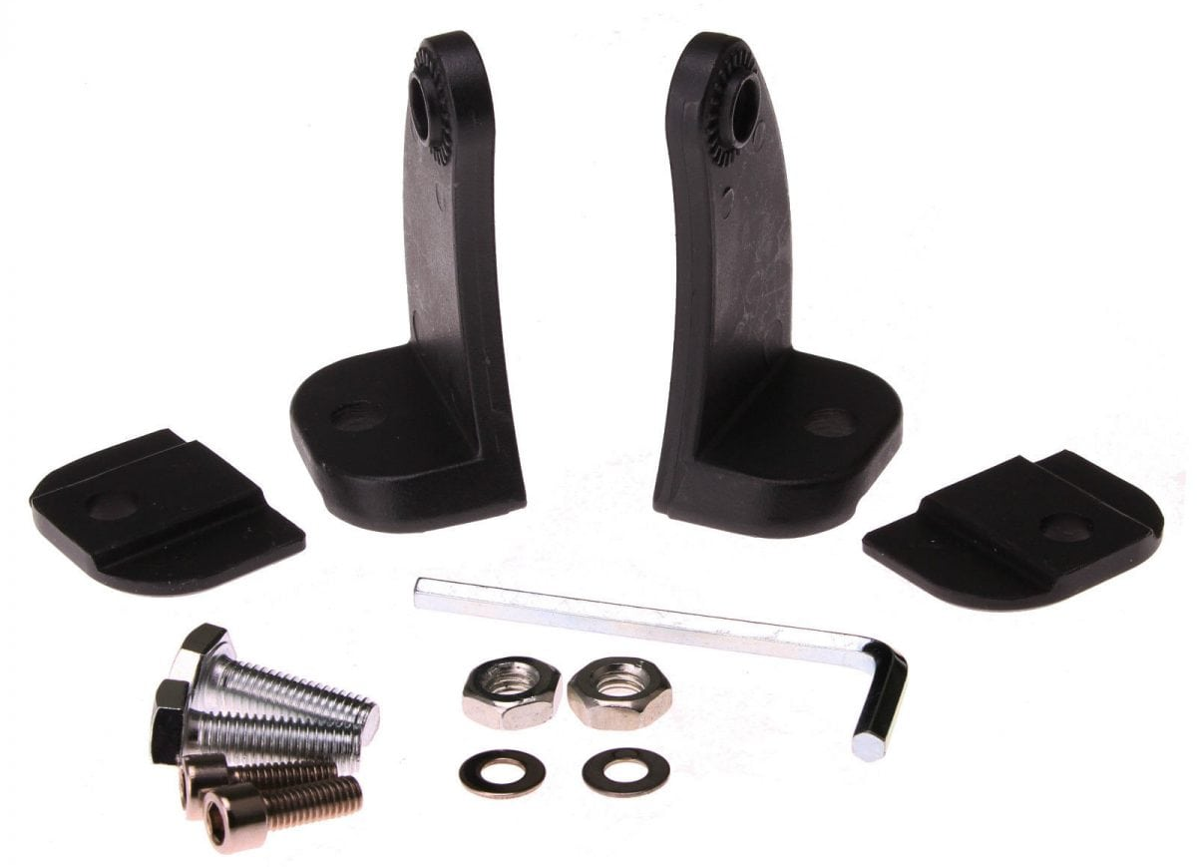

Prairie Falcon 31 Inch Off Road LED Light Bar Mounting Hardware

Instructions for Wiring and Operation

Installation and Wiring
To ensure proper installation installers are required to have a good understanding of automotive electronic systems and procedures for proper installation.
When you are drilling into the vehicle's surfaces, ensure that the area is free of any electrical wires, vehicle upholstery, fuel lines, etc. that could be damaged. All wiring passing through drilled holes should use grommets and silicone sealant to prevent wire or moisture damage when passing through compartment walls.
WARNING! Larger wires and secure or tight connections will ensure longer service life for your product. It is highly recommended that soldered connections have heat shrink used to protect the connection. Special attention should be given to the location and method of splicing wires to make electrical connections to protect these splices from lost power or connection and corrosion.
Insulation displacement connectors are not to be used. To reduce voltage drop, minimize the number of splices in the wires. The current carrying capacity of wires and fuses will be significantly reduced under high ambient temperature (e.g. under the hood).
All wires should be in accordance with the minimum wire size and other recommendations made by the manufacturer and be protected from hot surfaces and moving parts. Grommets, cable ties, looms, and other installation hardware should be used to anchor and protect all wiring. Fuses should be properly sized and located as close to the power take off points as possible to protect the wiring and device. To protect against short circuits, a fuse is included by LED Equipped for all products. Do NOT use a fuse with a higher amp rating than the initial fuse included. Due to the large current draw of off road LED lighting equipment, it is highly recommended that the installer consider the use of a 12v relay for powering your off road LED equipment. LED Equipped products do not currently include a 12v relay for installation of off road lighting on your vehicle, and use of a 12v relay should be sized properly and installed by a qualified off road equipment installer.
After removing your product from the packaging, ensure that you conduct a full bench test of your product prior to installation on your vehicle. To do this, connect your product 12v + (positive) and 12v – (negative) to an appropriate 12v + (positive) power source and 12v- (negative ground). Installers will typically want to use the 12v – (negative) battery terminal over a frame-ground installation for proper operation. Once connected to an appropriate 12v power source (and GND), test each functional element of your product to ensure proper operation. If it is identified that any function is not working properly as a result of your bench test, please contact LED Equipped for further diagnosis and resolution. DO NOT in any circumstance attempt to open the product light housing to investigate and resolve the issue on your own. Doing so will result in voiding of the factory warranty. Once a successful bench test has been completed, and you have ensured the proper operation of your product, please follow the instructions below to install your product in your vehicle.

Installing the Prairie Falcon 31 Inch LED Off Road LED Light Bar

The Prairie Falcon 31 Inch LED Off Road Light Bar is fully encapsulated, weather and vibration resistant, and comes configured with two (2) wires for ease of installation. Included with your Prairie Falcon 31 Inch LED Off Road Light Bare are the mounting hardware that can be used to affix your LED off road light bar to your vehicle. Depending on the desired location and placement of your Prairie Falcon 31 Inch LED Off Road Light Bar, alternate mounting hardware may desired and utilized at the installer’s discretion. All mounting hardware that is used for mounting should be made of stainless steel in order to prohibit degradation from exposure to the elements.

Installers must ensure that the Prairie Falcon 31 Inch LED Off Road Light Bar is securely affixed to your vehicle’s exterior before operating your vehicle. Due to the nature of off road LED lighting usage, insecure mounting of your Prairie Falcon 31 Inch LED Off Road Light Bar on your vehicle could result in damage to your vehicle or to persons operating in or around your vehicle.

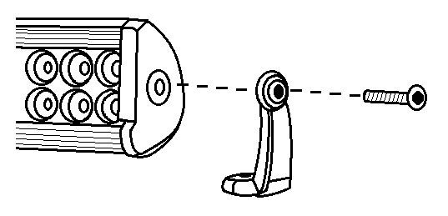

Included with the Prairie Falcon 31 Inch Off Road LEDLight Bar are two sets of mounting brackets and hardware. One set includes mounting hardware that attaches to both ends of the light bar, with feet that can be secured directly to your vehicle, as shown in Figure 1 to the left. .
Figure 1

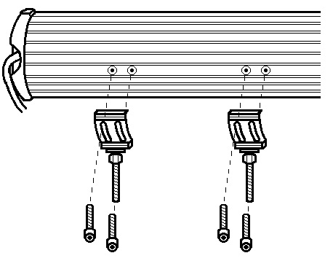

Also included with the Prairie Falcon 31 Inch LED Off Road LED Light Bar are brackets that secure directly to the rear of the light bar, and can be adjusted so that the mounting hardware can be secured to your vehicle quickly and easily, as shown in Figure 2 to the right.

Both mounting options come with all of the necessary hardware to secure your Prairie Falcon 31 Inch Off Road LED Light Bar to your vehicle and allow for a truly unique, customized, installation.

Figure 2

Wiring the Prairie Falcon 31 Inch LED Off Road Light Bar

The Prairie Falcon 31 Inch LED Off Road Light Bar should be hard wired to an external switch according to the wiring specifications included in Figure 3 below. Please note that the 12v + (Positive/Red Wires) and 12v – (Negative/Black Wires) wiring connections must be made to an appropriate 12v power source and ground in order for your Prairie Falcon 31 Inch LED Off Road Light Bar to function properly.

All wiring connections should be secured using appropriate automotive connectors or through the use of soldered connections and all wiring utilized should be appropriately sized for the application. All connections should be protected by using heat shrink wire wrap in order to protect the connection. Special attention should be given to the location and method of splicing wires to make electrical connections to protect these splices from lost power or connection and corrosion.

Figure 3

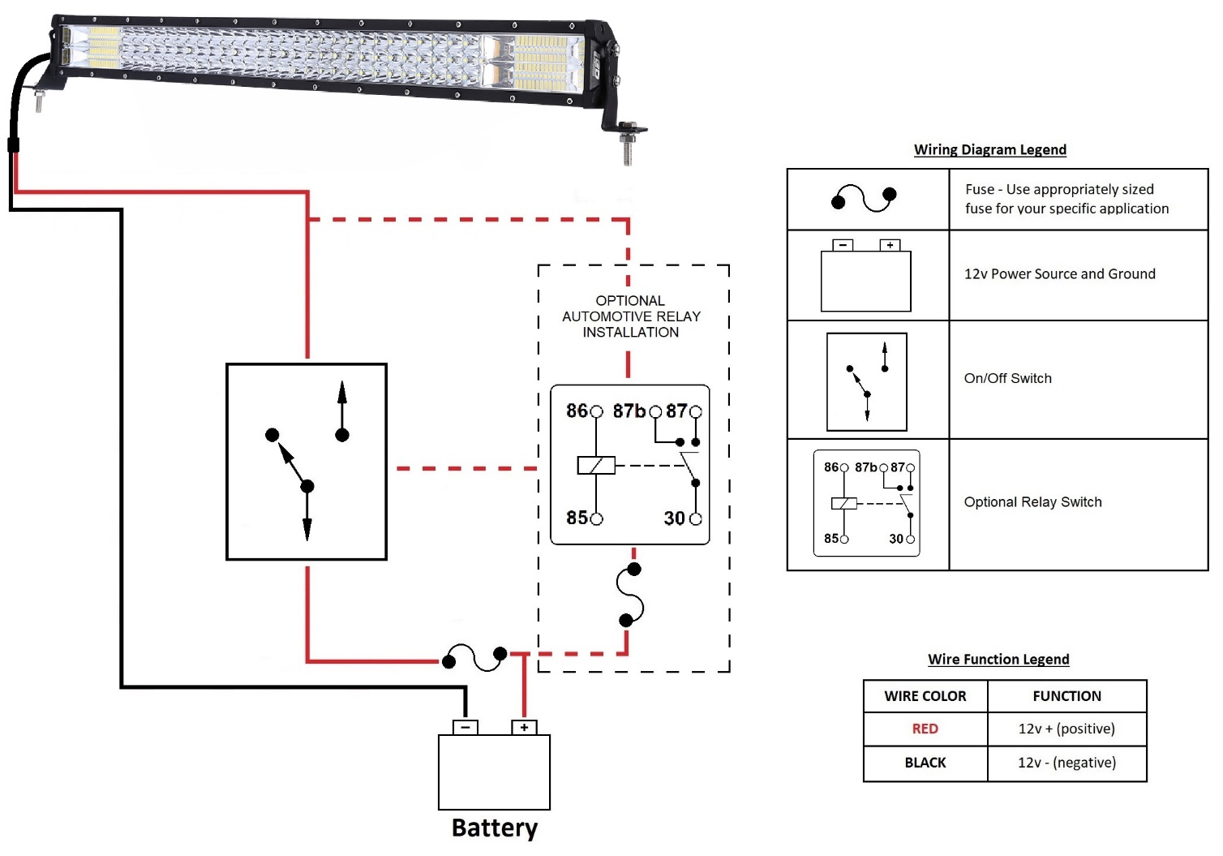

At LEDEQUIPPED, we know that you need affordable lighting for your police, EMS, fire, construction, or towing vehicles and that safety and reliability are important to you. That’s why all of our LED products feature powerful, up to date Generation LED lighting, perfect for your police, fire, construction, or EMS vehicle. LED Equipped focuses on a mission to carry out business ethically and with integrity, provide powerful products of the highest quality, maintain excellent and affordable prices, and to establish an unparalleled costumer service relationship beginning with establishing trust with our customers. As a provider of emergency vehicle lighting, we value the honesty, professionalism, and expertise present within our customer base.
For any questions regarding our products, contact us by calling us at +1 800-846-3940 or email us at sales@ledequipped.com.

