Swift 3.0 TIR 3 Watt LED Emergency Vehicle Grill Warning Light Head

Operating Manual and Installation Instructions

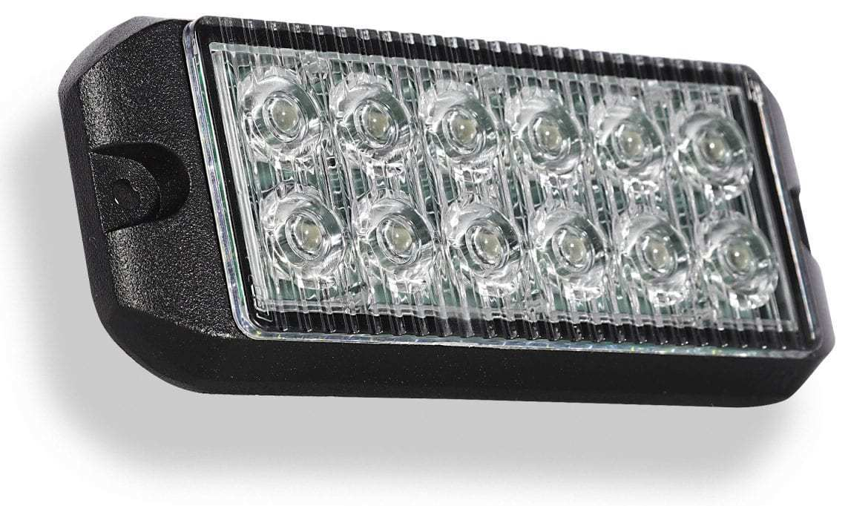

Swift 3.0 TIR 3 Watt LED Emergency Vehicle Grill Warning Light Head

Operating Manual and Installation Instructions

Warnings and Notices for Users and Installers
WARNING: Take CAUTION when installing
This document must be delivered to and read by the end user and installer as it serves to provide you with the required information for proper and safe use of your LEDEQUIPPED product. Before operating this or any LEDEQUIPPED products the user and installer must read this manual all the way through. You will find important information in this manual that could prevent property damage and/or serious injury to the user and installer. LEDEQUIPPED products are intended to alert pedestrians and other operators of the presence of personnel, the operation of emergency vehicles, an emergency site, and any warning needs. It is your responsibility to make sure you can proceed safely before driving against traffic, entering an intersection, responding to a high rate of speed, or walking on or around traffic lanes.
Your LEDEQUIPPED emergency vehicle devices should be tested daily to insure the device and all its functions are operating correctly. If you experience a malfunction contact LEDEQUIPPED's Customer Service immediately for troubleshooting options, or a warranty or service claim. You must ensure sure that the projection of the visual and audible is not blocked by vehicle components (i.e.: open trunks, visors, compartment doors), vehicles, other obstructions, or people. LEDEQUIPPED's sirens and other audible devices project sound in a forward direction and should be installed in a forward direction that faces away from the occupants of the vehicle.
This is professional grade equipment and is intended for strict use by authorized personal only. It is the user's responsibility to understand and obey all laws regarding emergency warning devices. You must know and be familiar with all applicable city, sate, and federal laws and regulations prior to the use of emergency vehicle warning devices. LEDEQUIPPED assumes no liability for any loss resulting from the use of this warning device. Proper installation is vital to the performance of the warning devices and safe operation of the emergency vehicle. Since the operator is under stressful environments the equipment must be properly wired and mounted to ensure effectiveness and safety. Therefore, controllers must be properly installed and placed within convenient reach of the operator so eye contact with the roadway is never lost. The effectiveness of your LEDEQUIPPED equipment is highly dependent upon correct mounting and wiring.
Improper wiring and mounting of the warning device will reduce the output and performance of the equipment. Emergency warning devices frequently require high electrical voltages and/or currents. Properly protect and use caution around live electrical connections. Grounding or shorting of electrical connections can cause high current arcing, which can cause severe personal injury and/or serious vehicle damage, including fire. Electromagnetic interference can be caused by many electronic devices used in emergency vehicles. To ensure that this doesn't happen to you, lights bars should be mounted a minimum of 12" - 34" from the radio antenna and do not power your equipment from the same circuit or share the same grounding circuit with radio communication equipment. After installation test all the vehicles equipment together to ensure everything operates free of interference. Driver and/or passenger airbags bags (SRS) will impact the way you mount your equipment. Any equipment installed in the deployment area of the airbags will damage or dislodge the airbags and sensors. This will also reduce the effectiveness of the airbags to protect the passengers and therefore these areas must be avoided. Installers must make sure that this equipment along with any parts, hardware, wiring, power supplies, and switch boxes do not interfere with the airbags, SRS wiring, or sensors. All LEDEQUIPPED equipment needs to be mounted and installed according to the vehicle manufactures instructions and securely attached to a part of the vehicle of sufficient strength to withstand the forces applied to the equipment. This device should be permanently mounted within the zones specified by the vehicle manufactures. This especially applies to equipment mounted on the exterior of the vehicle to avoid dislodging. When mounting units on the interior of the vehicle by a method other than permanent mount is discouraged as the it may become to detached under aggressive driving conditions such as sudden breaking, collision, or swerving.

Important Points for Your Safety and Longevity of your Equipment
Installers are required to have a good understanding of automotive electronic, systems and procedures for proper installation.
- One should not stare directly into the LEDs as momentary blindness and/or eye damage may occur.
- One should not take any lights through a car wash. Use only water to clean the outer body/lens of your equipment. –
- One should not use a pressure washer to clean any LEDEQUIPPED products. Inspect and test your product daily to insure it operates properly and is mounted correctly.
- One should not cut wires or work on a unit while the unit is still connected to a power source.
- One should not install this product or rout any wires through or in the deployment area of the airbag. Doing so may cause serious personal injury as it will damage or reduce the effectiveness of the airbag by causing the unit to become a projectile.
Reference the owner's manual for your vehicle to find the airbag deployment area. The User/Installer assumes all responsibility to determine proper mounting location, based on providing ultimate safety to all passengers in the vehicle.
- If the product requires you to drill holes the installer must ensure that the drilling process does not damage any vehicle components or other vital parts. Check all sides of the mounting surface before beginning to drill. Make sure to deburr all drilled holes and remove any metal remnants or shards to avoid injury and wires from becoming spliced. Grommets are to be installed in all wire passage holes.
- For LEDEQUIPPED products to operate at optimum efficiency a secure and good electrical connection to the Batteries Ground Post must be made. The recommended procedure requires the unit's ground wire be connected directly to the NEGATIVE (-) battery post.

Instructions for Wiring and Operation

Installation and Wiring
To ensure proper installation installers are required to have a good understanding of automotive electronic, systems and procedures for proper installation.
When you are drilling into the vehicle's surfaces, ensure that the area is free of any electrical wires, vehicle upholstery, fuel lines, etc. that could be damaged. All wiring passing through drilled holes should use grommets and silicone sealant to prevent wire or moisture damage when passing through compartment walls.
WARNING! Larger wires and secure or tight connections will ensure longer service life for your product. It is highly recommended that soldered connections have heat shrink used to protect the connection. Special attention should be given to the location and method of splicing wires to make electrical connections to protect these splices from lost power or connection and corrosion.
Insulation displacement connectors are not to be used. To reduce voltage drop, minimize the number of splices in the wires. The current carrying capacity of wires and fuses will be significantly reduced under high ambient temperature (e.g. under the hood).
All wires should be in accordance with the minimum wire size and other recommendations made by the manufacturer and be protected from hot surfaces and moving parts. Grommets, cable ties, looms, and other installation hardware should be used to anchor and protect all wiring. Fuses should be properly sized and located as close to the power take off points as possible to protect the wiring and device. To protect against short circuits, a fuse is included by LEDEQUIPPED for all products. Do NOT use a fuse with a higher amp rating than the initial fuse included.

Wiring the Swift 3.0 TIR 3 Watt LED Emergency Vehicle Grill Warning Light Head

The Swift 3.0 TIR 3 Watt LED Emergency Vehicle Grill Warning Light Head is fully encapsulated, weather and vibration resistant, and comes configured with six (6) wires for ease of installation. Each Swift 3.0 TIR unit is easily configured to allow for multiple light heads to be flashing simultaneously or alternating with the included twenty-two (22) preconfigured flash patterns. The Swift 3.0 TIR 3 Watt LED Emergency Vehicle Grill Warning Light Heads have been designed for ease of installation and adaptation for use with an unlimited number of additional Swift 3.0 series light heads with limited additional wiring. This design allows for installers to create seamless integration of these units for your specific application.

All of the Swift 3.0 TIR light heads can be hard wired to an external switch according to the wiring specifications included in Figure 2 below. Please note that the 12v + (Positive/Red Wires) and 12v – (Negative/Black Wires) wiring connections must be made to an appropriate 12v power source and ground in order for your Swift 3.0 TIR light heads to function properly..

All wiring connections should be secured using appropriate automotive connectors or through the use of soldered connections. All connections should be protected by using heat shrink wire wrap in order to protect the connection. Special attention should be given to the location and method of splicing wires to make electrical connections to protect these splices from lost power or connection and corrosion.

All LEDEQUIPPED lights are equipped with non-volatile memory which will recall the last selected flash pattern when turned on. Selecting the preferred flash pattern is easily done by touching the yellow flash pattern selection wire to an appropriate 12v + (positive) power source. Please see Figure 3 below for a listing of the preconfigured flash patterns for your Swift 3.0 TIR light heads.

Fig. 2

Swift 3.0 TIR Light Heads
Wire Color | Function
Red | 12v + (Positive)
Black | 12v – (Negative)
Yellow | Flash Pattern Selection
Blue | Activation wire
White | Synchronization
Green | Cruise Mode

Fig. 3

Swift 3.0 TIR Light Head Flash Patterns
Pattern  Number | Function | Pattern  Number | Function
1 | Quad Burst – Split | 12 | Super Flash – Alternating *
2 | Quad Burst – All | 13 | Quad/Single with Quad Burst – Split
3 | Quad Burst – Alternating * | 14 | Quad/Single with Quad Burst
4 | Quad – Split | 15 | Accelerator - Split
5 | Quad – All | 16 | Accelerator – All
6 | Quad – Alternating * | 17 | Express Flash
7 | Single – Split | 18 | California Steady with Pulse
8 | Single – All | 19 | California Steady
9 | Single – Alternating * | 20 | Steady All
10 | Super Flash – Split | 21 | Cycle Flash – Split and All
11 | Super Flash – All | 22 | Off

Selecting the Swift 3.0 TIR LED Emergency Vehicle Grill Warning Light Head Flash Pattern

Once your installation of the Swift 3.0 TIR light heads have been installed and wired in accordance with the wiring instructions identified above, selection of the preferred flash pattern can be performed by touching the yellow flash pattern selection wire to an appropriate 12v + (positive) power source. This will allow you to cycle through the flash patterns noted above to select the desired pattern. Note that all LEDEQUIPPED lights are equipped with non-volatile memory which will recall the last selected flash pattern when turned on.

Single Flash Pattern
Configuring the Swift 3.0 TIR 3 Watt LED Emergency Vehicle Grill Warning Light Heads to operate on a single flash pattern requires that each Swift 3.0 TIR light head be properly connected to an appropriate 12v + (positive) and 12v – (negative) power source. In addition, each light head can be synchronized to flash using the same selected pattern on each additional light head by connecting the white wires on each Swift 3.0 series light head. This installation method will result in a synchronization of all installed light heads.

To configure all Swift 3.0 TIR light heads to operate using a single preinstalled flash pattern, connect the 12v + (positive - red wires), 12v – (negative - black wires), synchronization (white wires), and pattern selection (yellow wires) together from each light head. Connect the light heads to an appropriate 12v + (positive) power source to power on the light heads. When powered on for the first time, it is necessary to synchronize the light heads by applying the pattern selection wire (yellow wire) to an appropriate 12v + (positive) power source for 3 seconds until each light head flashes momentarily. Releasing the pattern selection wire once each light head has flashed momentarily will result in resetting the pattern selection to the steady burn on all light heads. Once each light head is at a steady burn, using the bundled yellow flash pattern selection wires will allow you to cycle through the available flash patterns by touching the pattern selection wires to an appropriate 12v + (positive) power source momentarily. Once the desired pattern is selected, cap off the pattern selection wires to ensure that they do not inadvertently come into contact with a 12v + (positive) power source and change pattern selection.

All Swift 3.0 TIR light heads come with a non-volatile memory which will automatically recall the last pattern selected when powered on.

Alternating Flash Pattern
Swift 3.0 TIR light heads come preinstalled to allow for the configuration of alternating flash patterns. Please note that alternating flash pattern selection utilizes independent flash pattern configurations, and therefore only of a subset of the regular flash patterns, specifically designed for alternating light head installations, is available.

Alternating flash patterns on your Swift 3.0 TIR light heads are easily set up by first making sure that each Swift 3.0 TIR light head is properly connected to an appropriate 12v + (positive) and 12v – (negative) power source. In addition, connect each light head that will be synchronized to flash using the alternating flash pattern using the white wires on each Swift 3.0 series light head. Each light head that will be synchronized together, in a group in the alternating flash pattern, should be bundled together using the pattern selection (yellow) wires on each Swift 3.0 series light head, and appropriately divided into two alternating groups. All light heads should be programmed to the same pattern to begin programming of alternating flash patterns. To synchronize the light heads to a common flash pattern, applying the pattern selection wire (yellow wire) from all light heads to an appropriate 12v + (positive) power source for 3 seconds until each light head flashes momentarily. Releasing the pattern selection wire once each light head has flashed momentarily will result in resetting the pattern selection to the steady burn on all light heads. To prepare for programming an alternating flash pattern, advance each light head to the next flash pattern (Quad Burst). All light heads should flash using the Quad Burst pattern in a synchronized manner at this time.

Please refer to Figure 4 below for a visual representation of how to wire multiple light heads in an alternating pattern configuration.

Figure 4

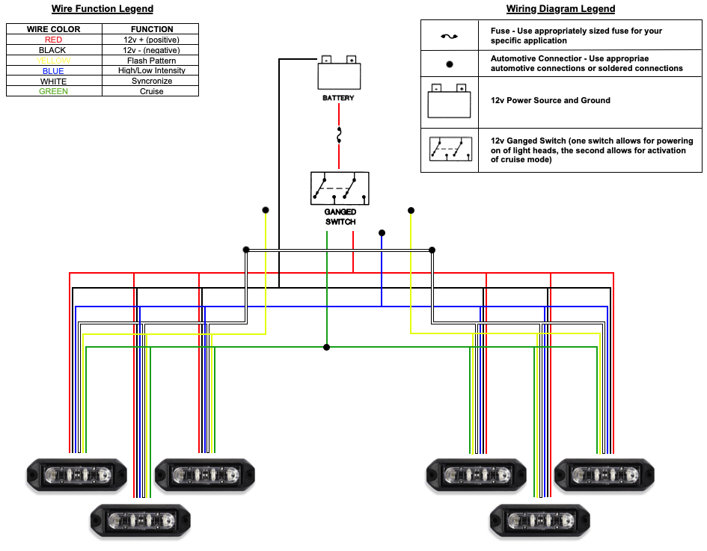

Once each group of light heads has been appropriately wired together (12v + [red wire], 12v – [black wire], synchronization [white wire], and flash pattern [yellow wire]), take the yellow wires from one of the groups of light heads, and contact a 12v + (positive) power source for approximately 6 seconds until each of the lights in the group flashes once and then returns to the flash pattern. This will configure one group of light heads to alternate flash patterns with the other group.

To cycle through alternating flash patterns, connect the groups of bundled yellow wires from all light heads to a 12v + (positive) power source momentarily. Each time the group of bundled yellow wires is momentarily connected to a 12v + (positive) power source will advance to the next available flash pattern. Please note that only a subset of the preinstalled flash patterns has been designated for use in an alternating pattern installation.

To return to a synchronized flash pattern, the same steps should be applied. Split the groups of alternating light heads, using the flash pattern selection (yellow) wires. Take the yellow wires from one of the groups of light heads and contact a 12v + (positive) power source for approximately six (6) seconds until each of the lights in the group flashes once and then returns to the flash pattern. This will return the light heads to a synchronized flash pattern. Some installations may want the flexibility of being able to switch from alternating flash patterns to synchronized flash patterns as needed. This can be accomplished by connecting one group of bundled yellow wires from the alternating light heads to a momentary switch within the vehicle, which when depressed for approximately six (6) seconds will switch between alternating and synchronized flashing.

All Swift 3.0 TIR light heads come with a non-volatile memory which will automatically recall the last pattern selected when powered on.

Cruise Mode
Each Swift 3.0 TIR light head is also preconfigured to allow for a steady burn (cruise) pattern selection. This setup will allow for all connected light heads to operate at a steady burn when so configured. It is recommended that a separate switch or button is used on your lighting control box to power the cruse mode for individualized use of this functionality. To wire the cruise mode, connect the cruise mode wires from each light head together and connect the bundled cruise mode wires to a 12v + (positive) power source. When connected to a 12v + (positive) power source, cruise mode of your Swift 3.0 TIR light heads will become activated.

High/Low Intensity
Each Swift 3.0 TIR light head is preconfigured to allow for dimming of your light heads to a lower intensity This setup will allow for all connected light heads to operate at a lower intensity when so configured. It is recommended that a separate switch or button is used on your lighting control box to allow for individualized use of this High/Low Intensity functionality. To wire the High/Low Intensity, connect the High/Low Intensity (blue) wires from each light head together and connect the bundled High/Low Intensity wires to a 12v + (positive) power source. When connected to a 12v + (positive) power source, the lower intensity of your Swift 3.0 TIR light heads will become activated.

Swift 3.0 TIR LED Emergency Vehicle Grill Warning Light Head Optional Accessories

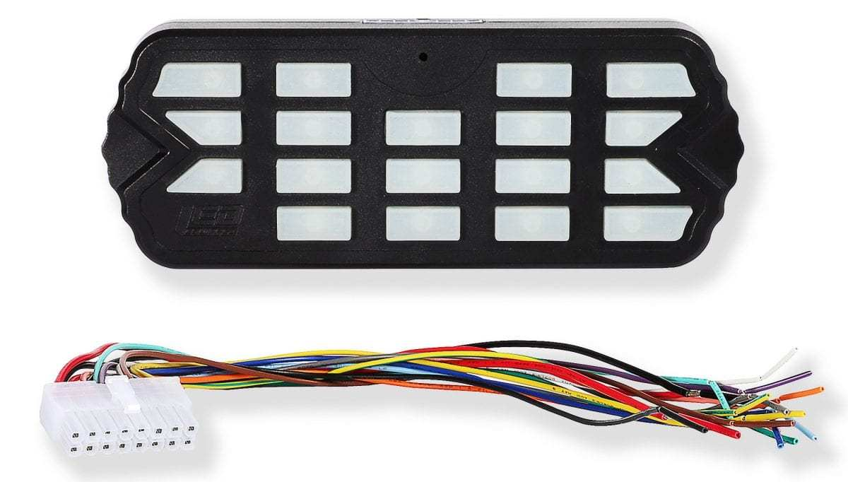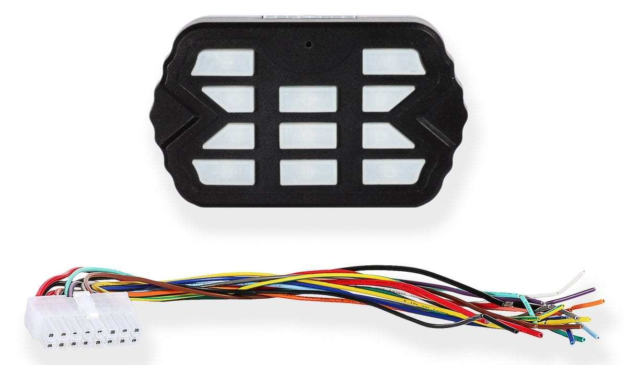
Combat Controller  Product Number: A-1516 | Combat Mini Controller  Product Number: A-1515
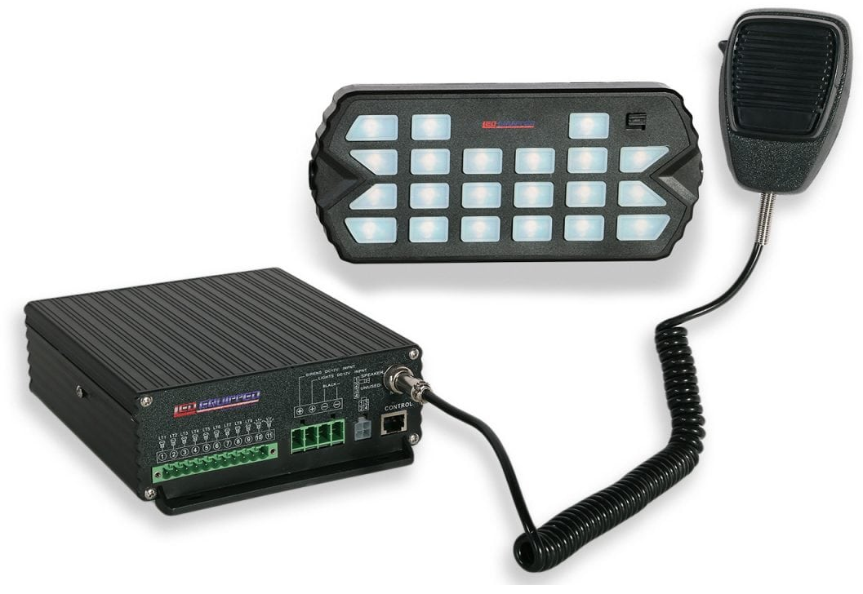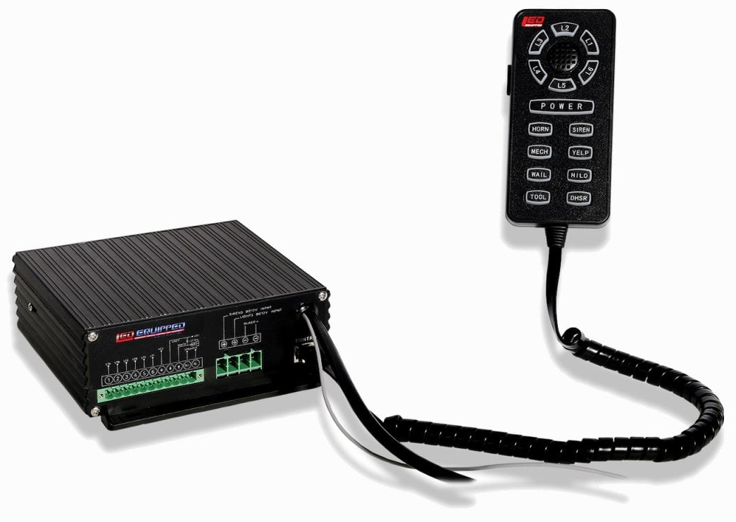
Black Falcon Siren and Control Unit  Product Number: A-1237 (100w) and  A-1368 (200w) | Pelican Siren and Control Unit  Product Number: A-1108 (100w) and  A-1109 (200w)
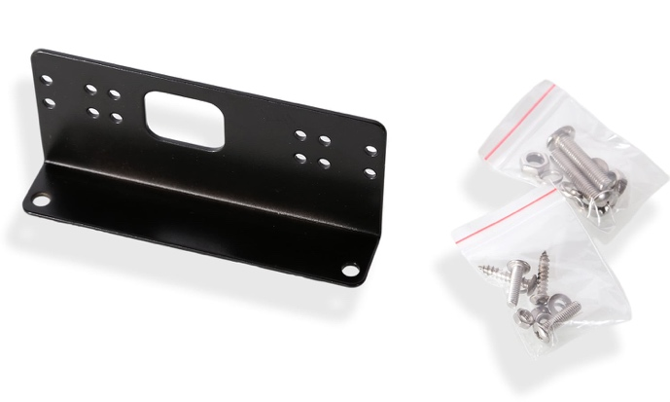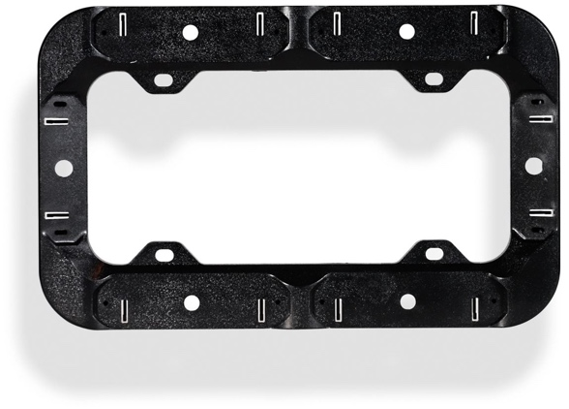
L-Brackets  (Product Number: A-1487) | Front/Rear License Plate Bracket  Product Number: A-1517

At LEDEQUIPPED, we know that you need affordable lighting for your police, EMS, fire, construction, or towing vehicles and that safety and reliability are important to you. That’s why all of our LED products feature powerful up do date Generation LED lighting, perfect for your police, fire, construction, or EMS vehicle. LEDEQUIPPED focuses on a mission to carry out business ethically and with integrity, provide powerful products of the highest quality, maintain excellent and affordable prices, and to establish an unparalleled customer service relationship beginning with establishing trust with our customers. As a provider of emergency vehicle lighting, we value the honesty, professionalism, and expertise present within our customer base
For any questions regarding our products, contact us by calling us at +1 800-846-3940 or email us at sales@ledequipped.com.

